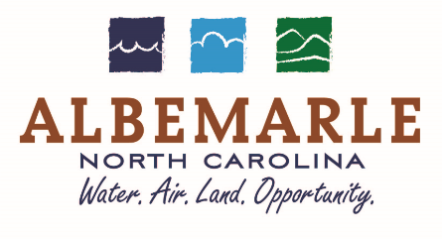
144 North Second Street
P O Box 190
Albemarle NC 28002-1090
March 6, 2025

PUBLIC NOTICE

Conveyance of Property to
Stanly Community College, BLET Program
Pursuant to G.S. 160A-280

WHEREAS, the City of Albemarle owns a 2007 Dodge Charger, Unit #102,
VIN # 2B3KA43G17H709176 and

WHEREAS, North Carolina General Statutes 160A-280 authorizes a City to donate personal property to another nonprofit organization, and

WHEREAS, the City of Albemarle has deemed these items to be surplus, obsolete, or unused

THEREFORE, THE CITY OF ALBEMARLE RESOLVES THAT:
The City Council of the City of Albemarle will consider conveyance without consideration a 2007 Dodge Charger, Unit #102, VIN # 2B3KA43G17H709176, to Stanly Community College, BLET Program, at their Regular Meeting on Monday, March 17, 2025, 6:30 p.m.

CITY OF ALBEMARLE

Jacob W. Weavil
Finance Director

PUBLICATION DATES: March 7 – 12, 2025

